**CSCI 6314 Money Management – Real Estate**

1. Do an analysis of buying a home vs. Renting. Please list pros and cons supported by analytical numbers. Please use spreadsheet to do the calculations.

**The results of analysis are provided (due to the fact that the author is single, the single person calculations and the conclusion inside the picture are provided. Also, Interest rate or First payment rate*100 = Interest rate or First payment rate percents):**

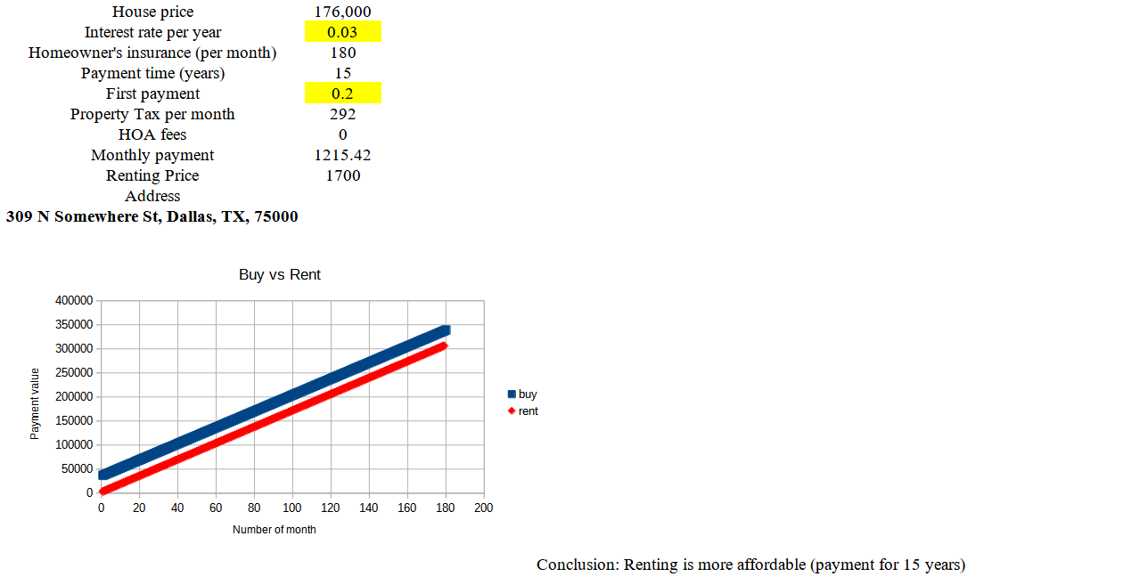

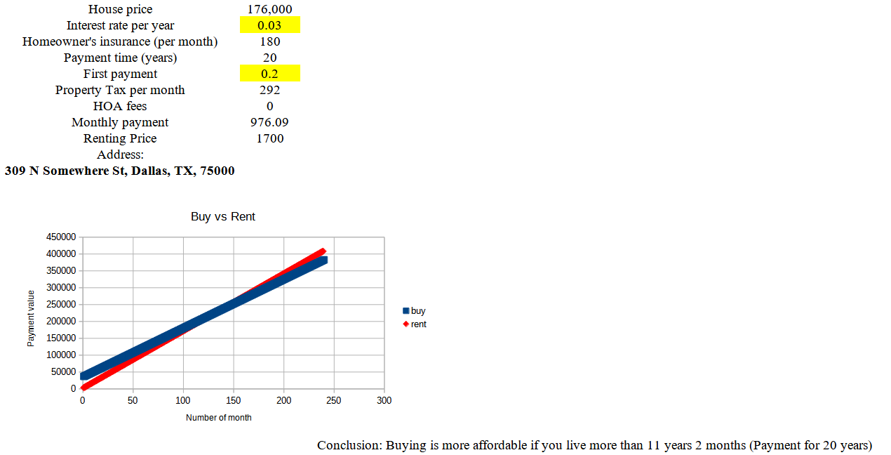

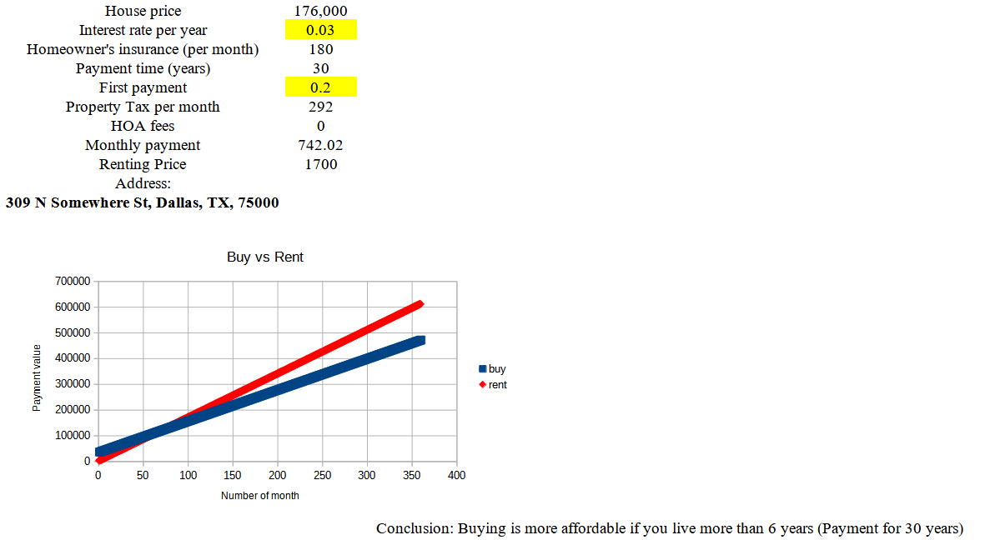

The case describes that the rent is much affordable for short time, but the buying might have less cost in long time. Of course, every case might be different, dependent on the interest rate, property tax, price, etc. Other pros and cons from general analysis of buying and renting:

a) In renting, the customer is limited in the choice and the lender, while the owner of the property might repair, sell, have huge freedom, have some tax benefits etc. Additionally, the owner might stop the contract.

2) In buying, the owner might have less flexibility of moving. Additionally, the home price might fluctuate, which makes the selling perspectives unpredictable. Also, the owner should deal with taxes and some unions managing houses (HOA, for example).

2. Do analysis on owning real estate (residential, commercial and land) for investment purposes.

**Let’s continue to analysis after buying the property provided above:**

a) If we pay 15 years, we have 1687.42$ to spend per month. If we provide the rent for $2000 per month, we can have 312.58$ per month, which is 3,750.96$ per year. Excluding the income tax 10%, we get 3,375.87$ income per year.

b) If we pay 20 years, we have 1448.09$ to spend per month. If we provide the rent for $2000 per month, we can have 551.91$ per month, which is 6,622.92$ per year. Excluding the income tax 10%, we get 5,960.63$ income per year.

c) If we pay 30 years, we have 1214.02$ to spend per month. If we provide the rent for $2000 per month, we can have 785.98$ per month, which is 9,431.76$ per year. Excluding the income tax 10%, we get 8,488.58$ income per year.

Other possible pros and cons from general analysis of having real estate:

Pros:

a) Unlike stocks, the owner of the real estate has the physical asset;

b) Your income is passive, which allows to focus on other things;

c) The increase of real estate value also increases the investment.

Cons:

a) Possible problems with tenants;

b) A possible surtax in the huge incomes;

c) Sometimes, it is impossible to cover mortgage rates with rental income;

d) It is impossible to sell the real estate immediately;